Ontic Health Model

Draft 0.04 5.26.2020

# Abstract

This document builds on “[Let’s Discuss the Situation](Lets%20discuss%20the%20situation.docx)” to define a generic model for information sharing and message interchange as well as the upper level of a healthcare specific model.

# Generic Model

## Actors

Actors include any entity (including people) that can *potentially* “act” in a situation, performing actions in any way. Performing actions does not necessarily include having responsibility for actions, such as machines under the control of people. Actors that can take responsibility are “social agents”, normally people and organizations.

Note that potentially acting and acting are not the same – actors take on “roles” with regard to situations reflecting that actual behavior or responsibility a particular actor has in various situations. Laws policies and conventions reflecting when an individual make take on such a role are reflected in the requirements for the role and do not constitute different kinds of actors. For example; when a person is of sufficient age and capacity to be considered legally responsible is defined differently within various jurisdictions and reflected in the role of being legally responsible. The general role of acting within a situation is the role “Participant”.

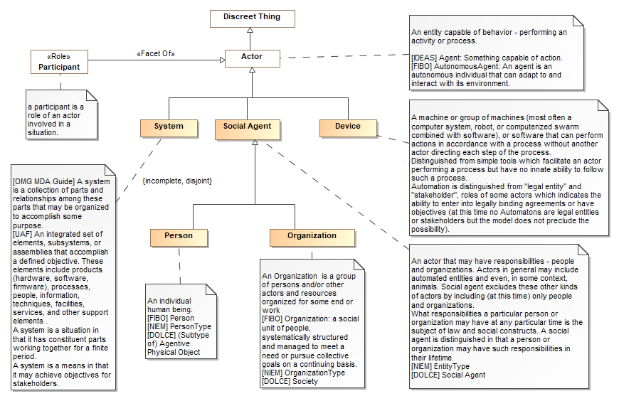

## Names and Identifiers

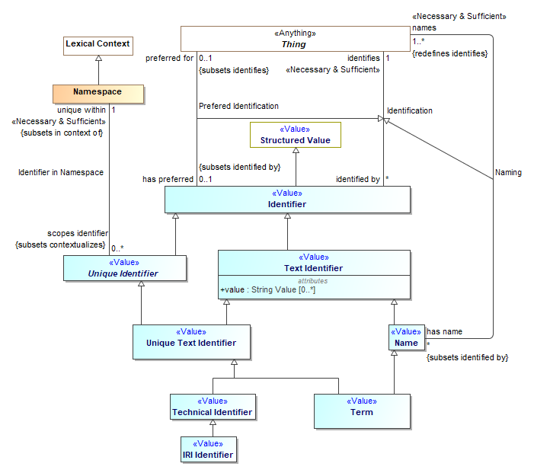

# Healthcare Model

## Clinical Situations

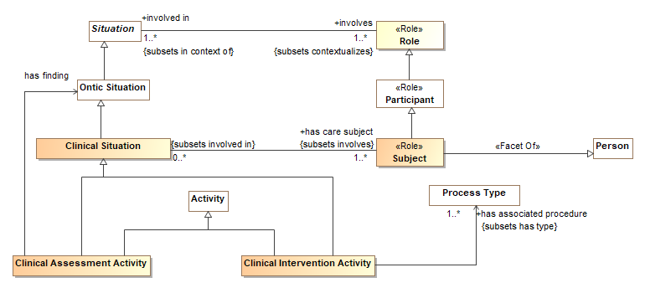

## Health Qualities

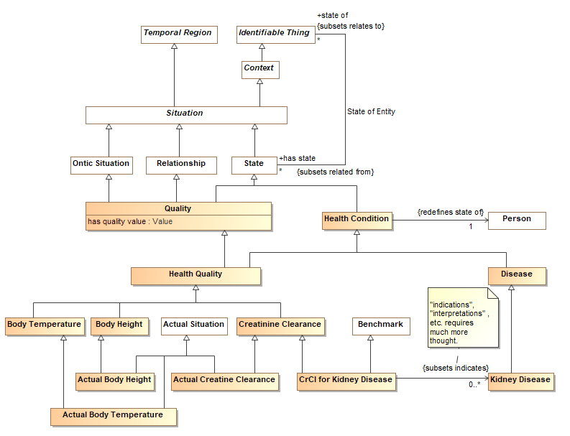

## Human Characteristics

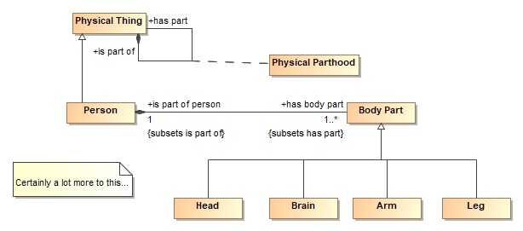

## Medications

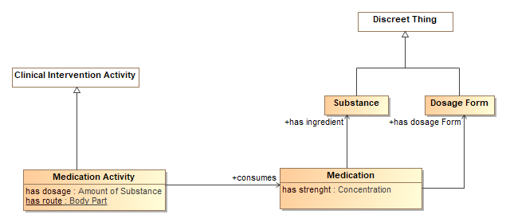

# Examples

Examples are represented by a ***graph[1]*** of information – nodes (instances of one or more classes) and edges, relationships between nodes. The notation used is UML instance diagrams.

Graphs have no specific “top”, they may be queried and navigated from any point, in any direction. Common graph technologies are W3C RDF[2] and Labeled Property Graphs[3].

## Checkup with temperature

John Snow’s medical record (started April 1998) shows he had a checkup on Jan 3rd from 10am to 11:30 am. John had is temperature taken by Jackie Chan at 10:30 am indicating his body temperature is 101.5 degrees Fahrenheit.

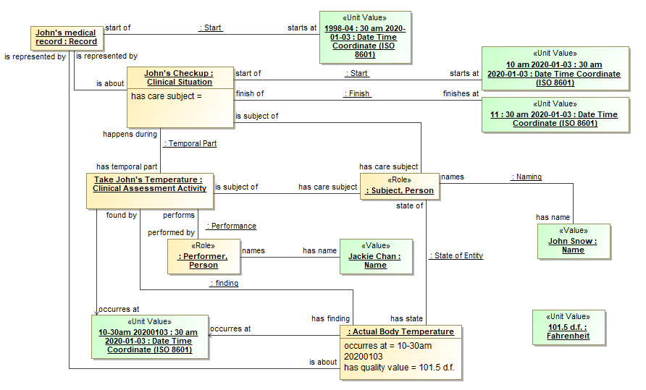

1. https://en.wikipedia.org/wiki/Graph_(discrete_mathematics)
2. https://www.w3.org/RDF/
3. https://en.wikipedia.org/wiki/Graph_database#Labeled-property_graph